College of Arts and Sciences

186 University Hall
230 North Oval Mall
Columbus, OH 43210

Phone (614) 292-1667
Fax (614) 292-8666
Web artsandsciences.osu.edu

June 1, 2011

Lawrence Krissek, Professor of Earth Sciences
Faculty Chair, CCI
College of Arts and Sciences

Dear Larry,

The Faculty Steering Committee has completed and submitted its proposal for a semester version of its interdisciplinary major: BA in Film Studies. The program was reviewed and unanimously approved by the Arts and Humanities Disciplinary Advisory Panel for Curriculum within the College of Arts and Sciences on May 11, 2011. Previously this minor was housed in ASC Interdisciplinary Programs Office, and with the re-structuring in Arts and Sciences has moved to be administratively housed in the Division of Arts and Humanities in the College of Arts and Sciences, with the Director of Film Studies directly reporting to the Divisional Dean. Please note that since this program crosses multiple units, the first line only on the PACER chart has been completed. Film Studies has an Assessment Plan on file, confirmed with OAA on October 15, 2010.

Most specifically, I have highlighted the changes for the program below:

BA in Film Studies: The BA in Film Studies was last revised and approved by CAA previous to 2006 as there are no ASC or CAA electronic records that indicate approval or revision after 2006. The BA is changing with minimal conversion. The program converted from 55 quarter credit hour, to 39 semester credit hours with one 3 credit hour pre-requisite. They have retained the same pre-requisite course, English 2264 (263), the same two core courses History of Art 2901 (260) and Film Studies 2271 (260), and the same categories. They have refined the requirements for the BA by formalizing a writing experience for their majors under the newly required Senior Seminar, and have added a Non-Fictional/Non-Industrial category requirement in place of two open Electives.

Minor in Film Studies: The Minor in Film Studies was last revised and approved by CAA previous to 2006 as there are no ASC or CAA electronic records of approval. The minor is changing with minimal conversion. There were five courses required on the quarter version for a total of 25 credit hours, and there are five courses required on the semester version for a total of 15 credit hours. The choice from among the five core courses is changed by one: English 2263 (263), German 3351 (299), History of Art 2901 (260) Women’s Studies 3317 (317), and English 373 is replaced with Film Studies 2270 Introduction to Film Studies. The requirement of four additional courses beyond the core choice remains the same, with two of the courses at the 4000-level or above, thus fulfilling the ASC requirement of 6 credit hours at the 3000-level or above.

We are sending these undergraduate programs forward for review and approval in the next stage of curricular review at the Arts and Sciences Committee on Curriculum and Instruction. The courses that are specific to all of the programs are listed under multiple Book 3 Listings. If you have any questions or concerns, please do not hesitate to call or email me at 292-5727 or williams.1415@osu.edu.

Thank you for your consideration of these proposals,
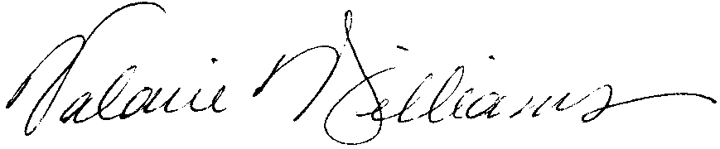
Valarie Williams, Professor of Dance
Associate Dean, College of Arts and Sciences, Arts and Humanities

CC: John Davidson, Director of the Film Studies Program and Associate Professor of GLL
Mark Shanda, Dean, College of Arts and Sciences, Arts and Humanities

